**Database Management System – cs422 DE**

**Lab 5 – Week 10 & 11**

-----------------------------------------------------------------------------------------------------------------

**This Lab is based on Transaction Management.**

* Submit your *own work* on time. No credit will be given if the lab is submitted after the due date.
* Note that the completed lab should be submitted in .doc, .docx, .rtf, .pdf or .zip format only.   
  ---------------------------------------------------------------------------------------------------------------

**Solve the following Exercises from the course text book.**

1. 22.18/20.18 (a, c, d, e) (5th/4th edition) – only do conflict serializable
2. **read (T1, balx), read(T2, balx), write(T1, balx), write(T2, balx), commit(T1), commit(T2)**

Not (conflict) serializable; not view serializable. Recoverable; avoids cascading abort.

1. **read (T1, balx), write(T2, balx), write(T1, balx), abort(T2), commit(T1)**

Assuming abort occurs, then only transaction T1 occurs making schedule serial and thus conflict serializable and view serializable. Without abort, then not (conflict) serializable; not view serializable. Recoverable; avoids cascading abort.

1. **write(T1, balx), read(T2, balx), write(T1, balx), commit(T2), abort(T1)**

Assuming abort occurs, then only transaction T2 occurs making schedule serial and thus conflict serializable and view serializable. Without abort, then not (conflict) serializable; not view serializable. Not recoverable therefore not avoiding cascading abort.

1. **read (T1, balx), write(T2, balx), write(T1, balx), read(T3, balx), commit(T1), commit(T2),commit(T3)**

Not (conflict) serializable; not view serializable. Recoverable but not avoiding cascading aborts.

1. 22.19/20.19 (a, c, d, e) (5th/4th edition)

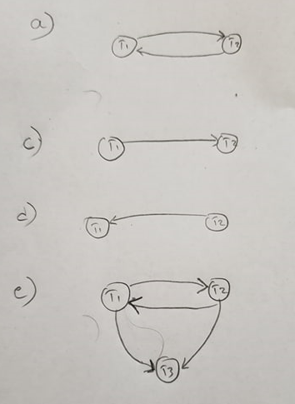

1. 22.22/20.22 (5th/4th edition)

